|  |
| --- |
| **Argentis Consulting** |
| **Apparel & Footwear** |
| DTW - Data Migration of POM DEFINITION & TEMPLATE |



**www.sapapparel.com**

Contents

1 INTRODUCTION 3

2 TEMPLATES 3

2.1 Templates related to POM Definition 3

1. U_ARGNS_POMS - U_ARGNS_POMS 3

2.1.1 Template: U_ARGNS_POMS - U_ARGNS_POMS 3

2.2 Templates related to POM Template 3

2.2.1 Template: ARGNS_POMTEMPLATE - ARGNS_POMTEMPLATE 3

2.2.2 Template: ARGNS_POMTEMPLATE - ARGNS_POMTEMPLNS 4

3 DATA IMPORT PROCESS 5

3.1 Excel Preparation for POM Definition 5

3.2 Excel Preparation for POM Template 6

4 CSV files import trough DTW –POM Definition 7

5 CSV files import trough DTW –POM Template 13

# INTRODUCTION

This document contains the necessary information to prepare and execute data migration for POM definitions and template using the DTW tool.

# TEMPLATES

## Templates related to POM Definition

To import data related to POM definition the following Excel templates need to be completed:

## 1. U_ARGNS_POMS - U_ARGNS_POMS

### Template: U_ARGNS_POMS - U_ARGNS_POMS

This is the template that will hold the general information for each POM definition at a header level.

The relevant fields in this template are:

1. Code: SAP Internal Code. This code is a sequence starting from 1. It must be unique

2. U_Description: Point of measurement description

3. U_ProdGroup: Product Group

## Templates related to POM Template

To import data related to POM template the following Excel templates need to be completed:

1. ARGNS_POMTEMPLATE - ARGNS_POMTEMPLATE

2. ARGNS_POMTEMPLNS - ARGNS_POMTEMPLNS

### Template: ARGNS_POMTEMPLATE - ARGNS_POMTEMPLATE

This is the template that will hold the general information for each POM template at a header level.

The relevant fields in this template are:

1. Code: SAP Internal Code. This code is a sequence starting from 1. It must be unique

2. U_CodeTmpl: POM template code

3. U_Desc: POM template description

4. U_ProdGrp: Product Group

5. U_Active: ‘Y’ to make active ‘N’ to make inactive

6. U_Scale: Scale code

7. U_SSize: Choose middle size code

8. U_MenType: The measurement type

### Template: ARGNS_POMTEMPLATE - ARGNS_POMTEMPLNS

This is the template that will hold the general information for each POM template at a detail level.

The relevant fields in this template are:

1. ParentKey: This is the SAP internal code defined in the code field of the ARGNS_POMTEMPLATE - ARGNS_POMTEMPLATE

2. LineNum: Leave blank. This field is automatically completed by DTW during the import process.

3. Code: This is the SAP internal code defined in the code field of the ARGNS_POMTEMPLATE - ARGNS_POMTEMPLATE template. Same as ParentKey

4. U_POM: Point of measurement code defined in the U_ARGNS_POMS - U_ARGNS_POMS template

5. U_Desc: Point of measurement description defined in the U_ARGNS_POMS - U_ARGNS_POMS template

6. U_SizeCode: Size code belogs to the scale code defined in the ARGNS_POMTEMPLATE - ARGNS_POMTEMPLATE

7. U_TolPosit: Positive tolerance

8. U_TolNeg: Negetive tolerance

9. U_QAPoint: ‘Y’ to select QA point ‘N’ to deselect QA point

Notes:

1. The ParentKey and Code will always have the same value and it must exist in the ARGNS_POMTEMPLATE - ARGNS_POMTEMPLATE.

# DATA IMPORT PROCESS

## Excel Preparation for POM Definition

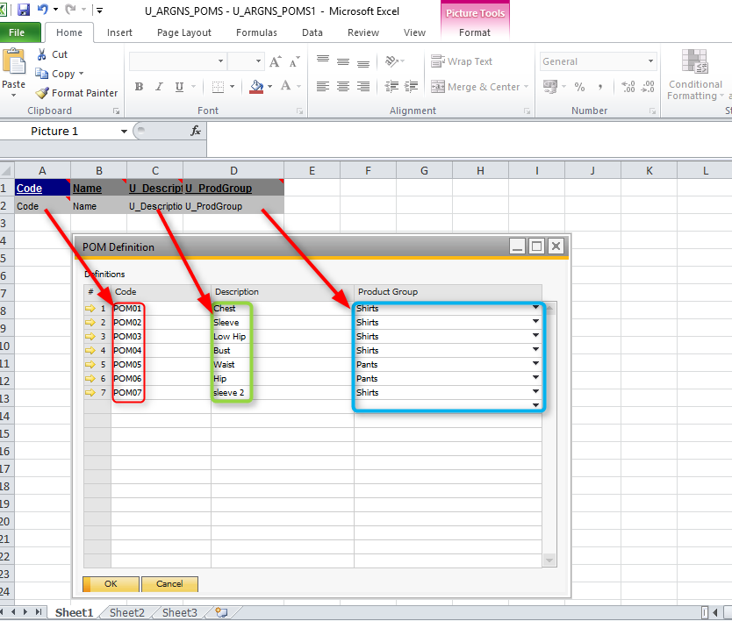

## Excel Preparation for POM Template

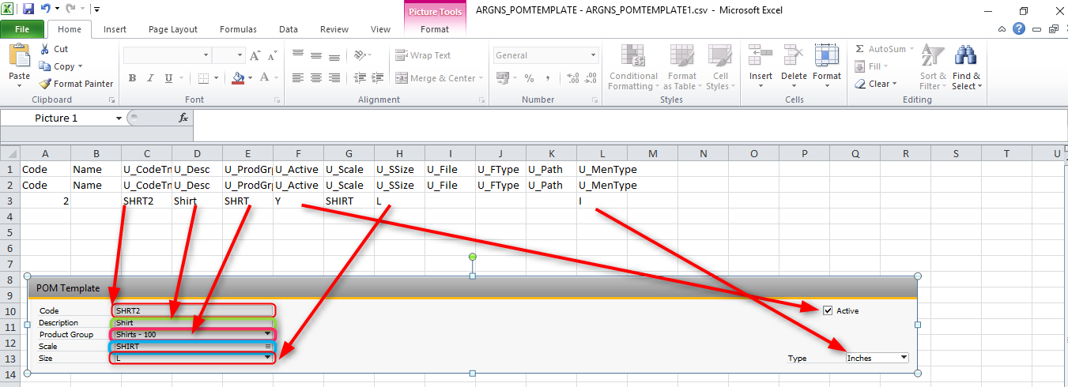

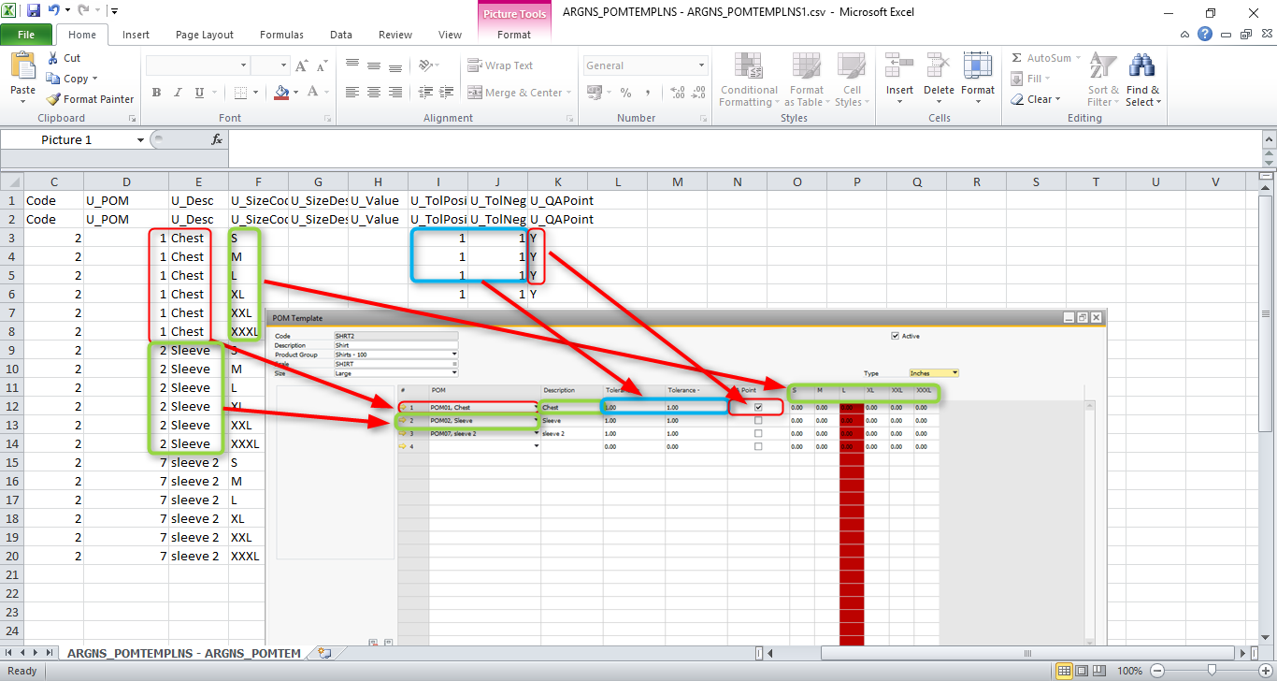

# CSV files import trough DTW –POM Definition

1. Click on the “Import” button to start the Data import wizard

2. Select setup data as the data type for importing POM definition

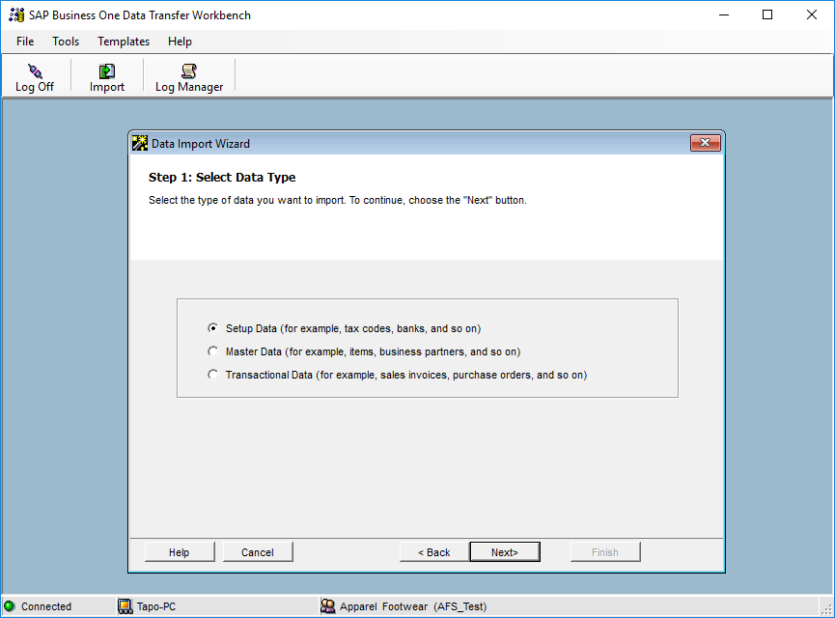

3. Select Add new data as the operation type (Please note that if you are working with already existing

styles, then select the Update existing data option or the Add new data and Update existing data if

you are going to be updating data and loading new data all in the same process).

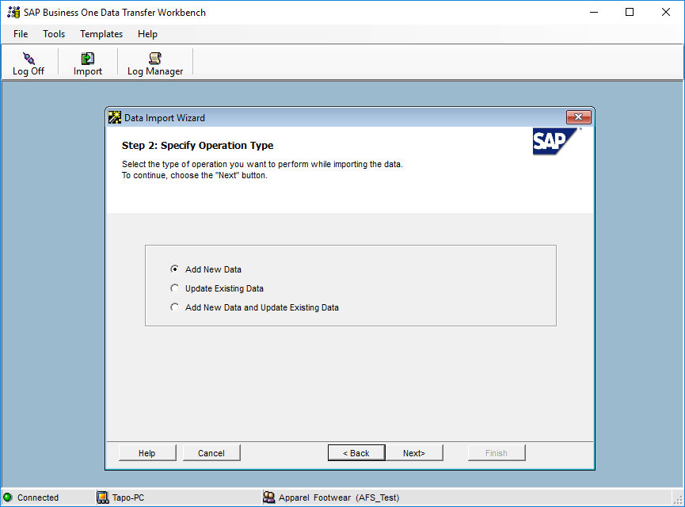

4. Search and select the UDT U_ARGNS_POMS user table under the following path: User Defined

Data > Table (UDT) > U_ARGNS_POMS

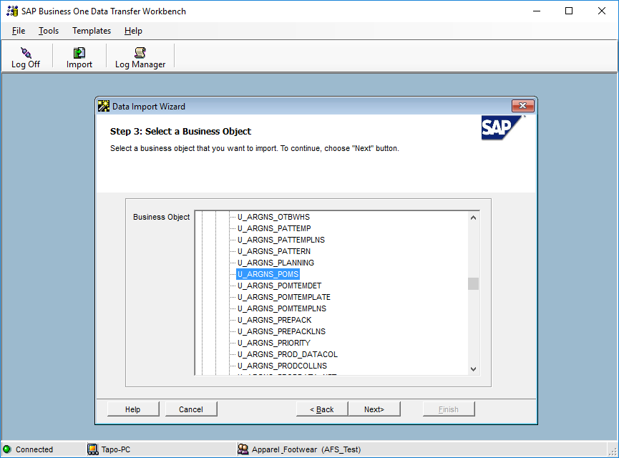

5. Select the templates corresponding to each POM definition table.

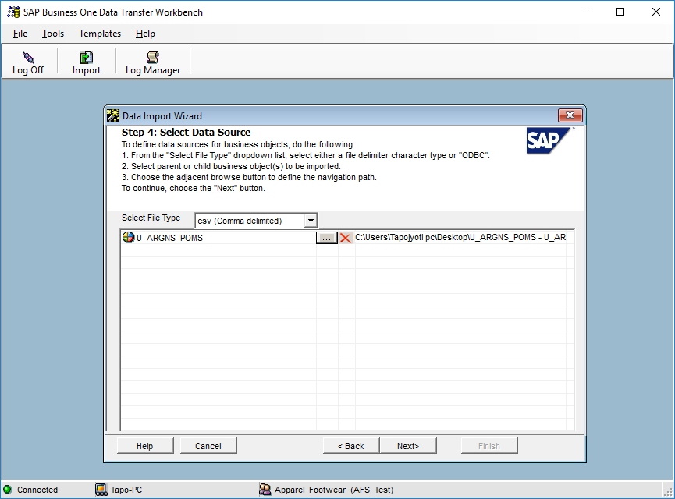

6. Map UDT fields. This is a confirmation screen for the data mapping.

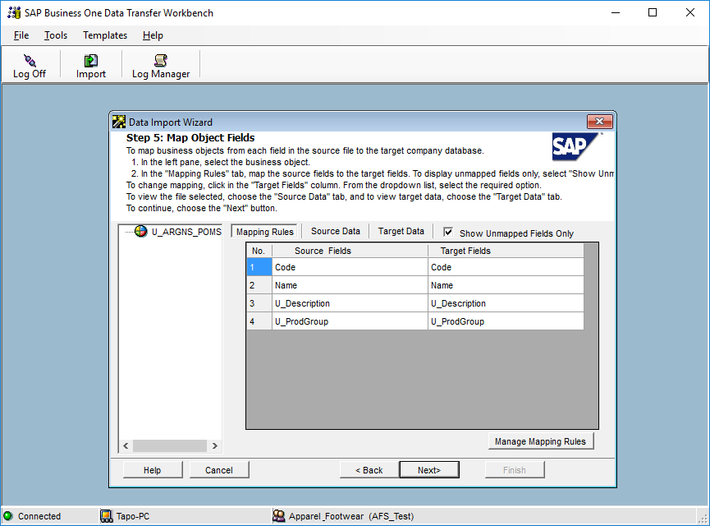

7. Define error handling. It is usually recommended to select the last option to prevent from processing the entire file if a certain number of errors are found. In this step it is usually recommended to run the simulation process (by clicking the Run Simulation button) to get a preview of the data import result.

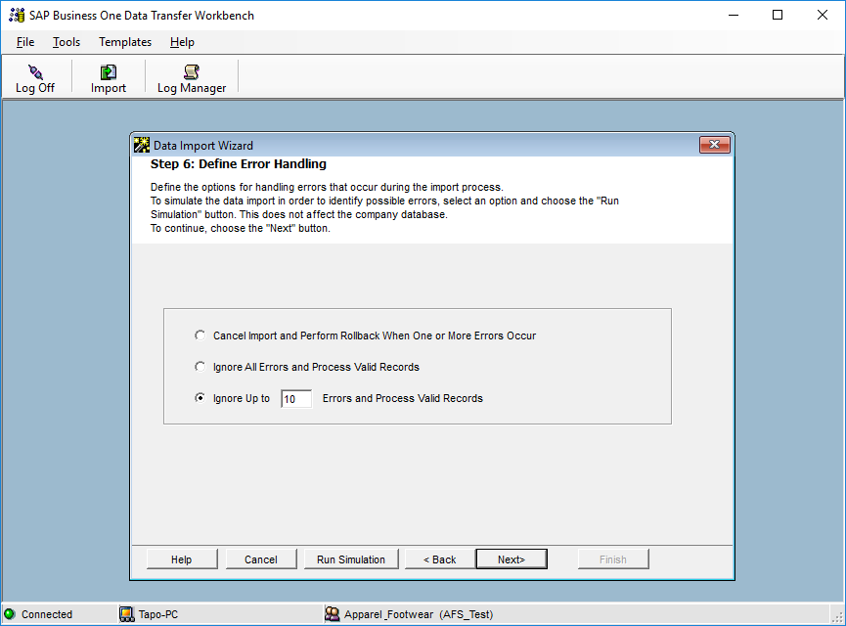

8. Start importing data. If no errors were found in the simulation process, click on the Import button to start the actual data import process. Please not that this does not guarantees that the data imported is accurate and it must be checked within SAP to make sure that everything is being loaded the way it should.

# CSV files import trough DTW –POM Template

1. Click on the “Import” button to start the Data import wizard

2. Select master data as the data type for importing POM template

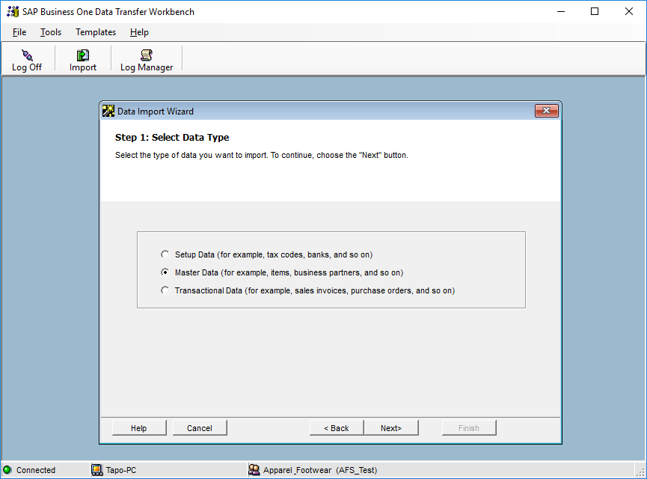

3. Select Add new data as the operation type (Please note that if you are working with already existing

styles, then select the Update existing data option or the Add new data and Update existing data if

you are going to be updating data and loading new data all in the same process).



4. Search and select the UDO_ARGNS_POMTMPL object under the following path: User Defined

Data > Object (UDO) > UDO_ARGNS_POMTMPL

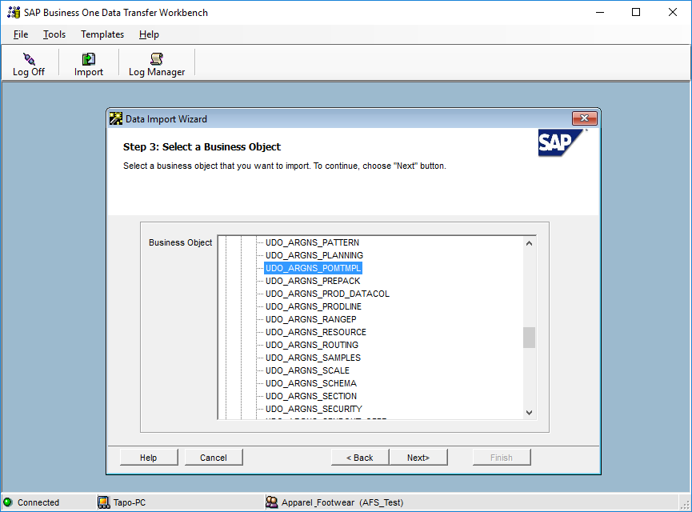

5. Select the templates corresponding to each POM template object.

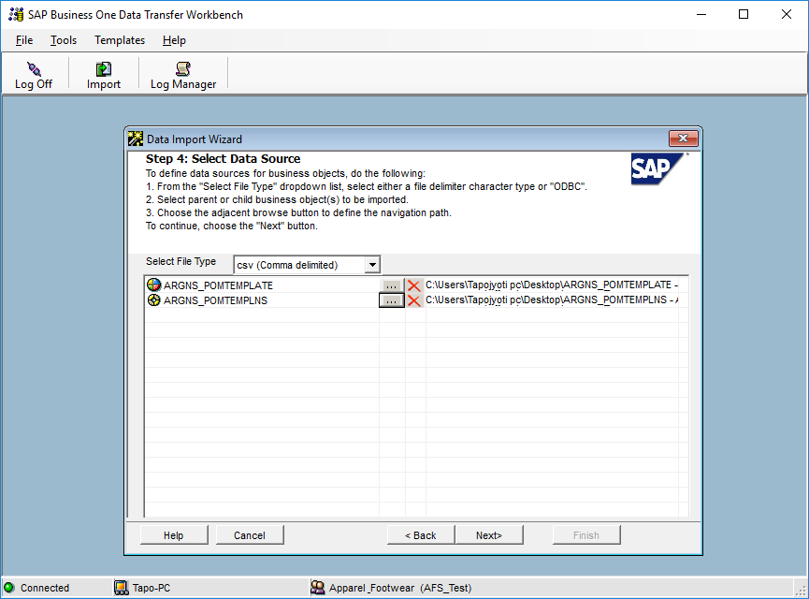

6. Map object fields. This is a confirmation screen for the data mapping.

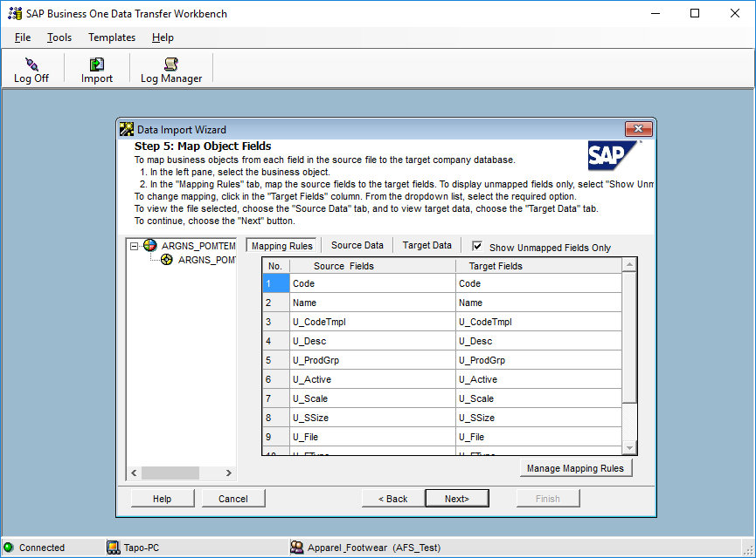

7. Define error handling. It is usually recommended to select the last option to prevent from processing the entire file if a certain number of errors are found. In this step it is usually recommended to run the simulation process (by clicking the Run Simulation button) to get a preview of the data import result.



8. Start importing data. If no errors were found in the simulation process, click on the Import button to start the actual data import process. Please not that this does not guarantees that the data imported is accurate and it must be checked within SAP to make sure that everything is being loaded the way it should.



**www.argentisconsulting.com**

**Argentis Consulting** is dedicated to the development, distribution and support of recognized certified solutions for SAP Business One, as an SSP (Software Solution Provider) with a Gold Partner status.

**CONTACT INFORMATION**

|  |  |
| --- | --- |
| **USA**  9744 NW 45th Lane  Doral, FL 33178  info@argentisconsulting.com | **ARGENTINA**  Ávila y Zarate 2048  Cerro de la Rosas, Córdoba,  CP 5009  Córdoba - Argentina  info@argentisconsulting.com |
| **CARIBEAN**  City View Plaza – Suite 301  48 Road 165  Guaynabo, PR. 00968  Puerto Rico  caribe@argentisconsulting.com | **SPAIN**  C/ Juan Bravo N° 3 A 28006  Phone: (+34) 91 123 7263  Madrid - Spain  info@argentisconsulting.com |